

Homework PACKET 12

iDAHO pUBLIC dRIVER eDUCATION

**BUYING & MAINTAINING A VEHICLE**

**TRIP PLANNING**

BUYING A VEHICLE

Do you need a vehicle or want a vehicle? Do your driving needs justify the expenses involved in buying, insuring, maintaining, and repairing an expensive piece of machinery? Can you afford these expenses while maintaining your grades as well as your family and social life?

If you CAN afford a vehicle, what kind of vehicle should you buy? Ask yourself the following questions:

* How long do you want to vehicle to last?
* Will you use it for short or long trips?
* How many miles do you expect to drive each year?
* How many passenger seats do I need?
* Will I need to haul or tow anything?
* What will I use it for most of the time?

Vehicle size plays an important part in safety, use, and fuel economy as does engine size and type. A smaller engine gets better gas mileage but has less power. Most vehicles today have automatic transmissions and are not only easier to drive but nearly as fuel efficient as stick shift vehicles. Automatic transmissions are usually more expensive to repair but don’t break down as often as manual transmissions.

Will you buy a new or used car? New cars will cost more and will immediately decrease in value the minute it’s driven off the lot but will likely be more reliable and include a warranty. Used cars will save you quite a bit of money but will require some research on the vehicle’s value and history. You will want to take a test drive have a mechanic do a full vehicle inspection before you make an offer.

Engine size and type



How much should you pay? Publications like the NADA guide (known as “the blue book”) will provide retail and wholesale prices for new and used vehicles. Knowing what a vehicle is worth before you buy or sell it can save you thousands. The value of a vehicle depends a lot on its condition so look at other similar vehicles for sale and always have a mechanic.

An alternative to purchasing a vehicle is leasing. You are responsible for the required monthly payments, fuel, and other operating costs just like buying a vehicle. However, the main difference is that after the lease period is over you don’t own the vehicle. At the end of the lease you may choose from one of these options:

1. Return the vehicle and lease another
2. Purchase the vehicle at the cost listed in the original contract
3. Return the vehicle and walk away

Leasing a vehicle is not for everyone. You may have to pay extra if you drive more than a certain number of miles and you may be charged extra fees if the vehicle is returned with more than normal wear.



Idaho public driver Educationducation

HOMEWORK PACKET 12

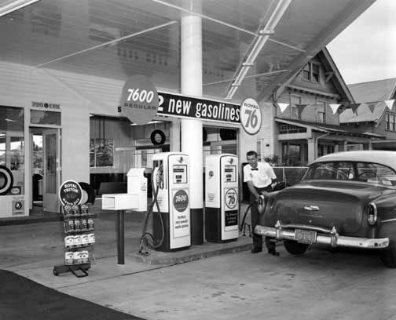

Gas stations used to provide regular maintenance for drivers in addition to pumping their gasoline; cleaning the windows, headlights, and taillights, and checking the oil, engine coolant, windshield washer fluid level, and tire pressure. At gas stations today, in most states, there is no one to do these things for you or to remind you.

FUEL-SAVING TECHNIQUES

Each year vehicles are increasingly more fuel efficient but there are still ways to save fuel and money.

Maximum fuel efficiency occurs between 50-55mph but strong winds, having windows down, and higher speeds all burn more fuel. When driving in the city, coast to a stop when possible. When accelerating, do so gradually.

Engines are the most efficient when they are warm; the best method of warming an engine is to drive it at moderate speeds for the first few miles. Modern vehicles do not need to sit idling for 5-10 minutes on cold mornings to warm up.

INSURANCE

Idaho law requires you to prove you can pay for damages you may cause as the result of a vehicle crash. This is “insurance” against the probability of damages. Your insurance rates are based on your age, marital status, driving record, miles driven, where you live, and vehicle type.

All states require its drivers to at least carry liability insurance. This protects the driver who cased the collision and covers others when you are at fault. It is the most important insurance to have.

Comprehensive insurance pays for repairing or replacing the owner’s car for reasons other than a collision. Vandalism or severe hailstorms are examples.

Collision insurance covers you if you are fault in a collision or if you are not able to collect from another driver who is was at fault.

MAINTENANCE

Owning a motor vehicle is a responsibility that includes keeping it in safe and good working condition.

Preventive maintenance is the routine care and attention you give your vehicle – mostly based on the recommended maintenance schedule in the vehicle’s owner’s manual. This regular care may be the best method of preventing expensive breakdowns down the road.

Part of preventive maintenance is checking for signs of fluid leaks before you drive. Purple fluid is likely power steering fluid, black is motor oil, green is engine coolant, and red is transmission fluid. If you see any of these colors beneath your vehicle it is a good idea to check or have those systems checked before driving.

REVIEW QUESTIONS

HOMEWORK PACKET 12

NAME: _______________________________________ DATE: ____________

DIRECTIONS: Answer the following questions based on what you learned from the homework packet.

1. The book that can help you find the real value of a new or used vehicle is known as the ______________
2. The three options at the end of a lease are:
3. The type of insurance all Idaho drivers must carry is called:
4. Name the type of fluid by the color:
   1. Red
   2. Purple
   3. Black
   4. Green
5. Name two things you can do to get better fuel mileage: